**Calculating bias for the logistic regression model we built.**

From the notebook, the confusion matrix for logistic regression model is

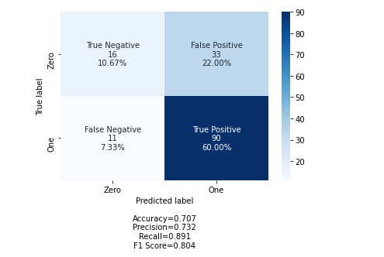

PPV = true positives \ (true positives + false positives)

PPV = 90 / (90 + 33)

PPV = 90/123

= 0.73 = 73%

NPV= true negatives\ (true negatives + false negatives)

NPV = 16 / (16 + 11)

= 16/27 = 0.59 = 59%

Bias is the nature of difference between PPV and NPV. The difference between this (73% and 59%) is indeed large, hence, we conclude that there is bias in the logistic regression.